**Assessment on Human Nutrition: Module 2**

**Submitted by Madit Majur Gabriel**

**Admission No. AIPMS/280/009/2018**

**Under the Supervision of Mr. Stephen Muchami**

**Course Moderator – Capacity Africa Institute**

**Submitted to the department of Nutrition for partial fulfillment and requirement for Diploma in Human Nutrition.**



**Department of Nutrition**

**Africa Institute for Project Management Studies**

**Muthaiga Shopping Complex, Limuru rd 4th floor Nairobi, Kenya,**

**October, 2018**

ASSIGNMENTS

1. **Describe functions of each region of the gastro intestine tract.**

**Mouth**

The mouth is the beginning of the digestive tract; and, in fact, digestion starts here when taking the first bite of food. Chewing breaks the food into pieces that are more easily digested, while saliva mixes with food to begin the process of breaking it down into a form your body can absorb and use. (Cleveland Clinic, 13/09/2018).

**Pharynx**

The pharynx (throat) is involved in both digestion and respiration. It receives food and air from the mouth, and air from the nasal cavities. When food enters the pharynx, involuntary muscle contractions close off the air passageways.

A short tube of skeletal muscle lined with a mucous membrane, the pharynx runs from the posterior oral and nasal cavities to the opening of the esophagus and larynx. It has three subdivisions. The most superior, the nasopharynx, is involved only in breathing and speech. The other two subdivisions, the oropharynx and the laryngopharynx, are used for both breathing and digestion. The oropharynx begins inferior to the nasopharynx and is continuous below with the laryngopharynx (Figure 6). The inferior border of the laryngopharynx connects to the esophagus, whereas the anterior portion connects to the larynx, allowing air to flow into the bronchial tree.

This diagram shows the cross-section of a human face and highlights the location of the pharynx, which runs from the nostrils to the esophagus and the larynx. Van Loon FPL (et.al.) 1988 - 1993.

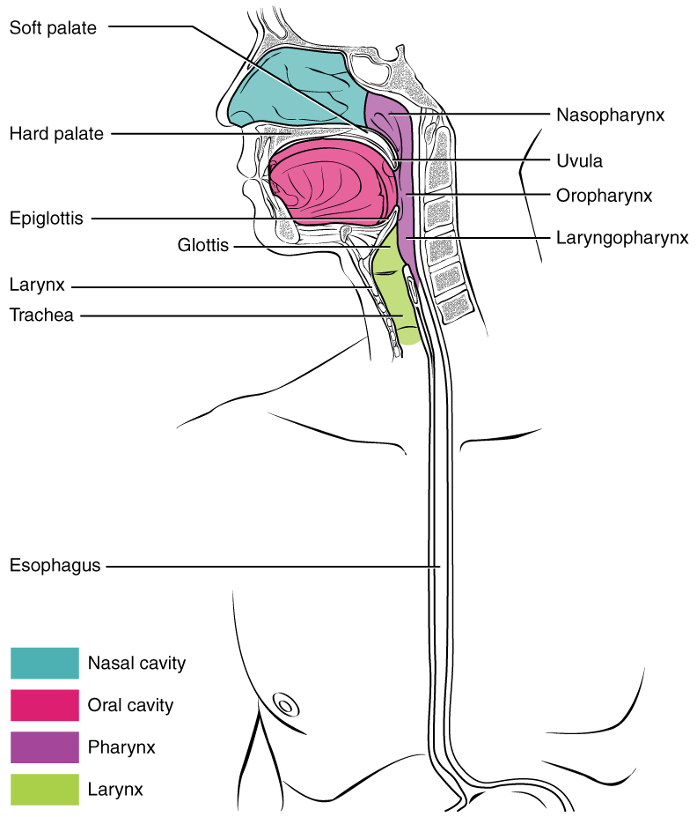

Figure 6. Pharynx. The pharynx runs from the nostrils to the esophagus and the larynx. <https://opentextbc.ca/anatomyandphysiology/chapter/23-3-the-mouth-pharynx-and-esophagus/>

**Esophagus**

Located in your throat near your trachea (windpipe), the esophagus receives food from your mouth when you swallow. By means of a series of muscular contractions called peristalsis, the esophagus delivers food to your stomach. (Cleveland Clinic, 13/09/2018).

**Stomach**

The stomach is a hollow organ, or "container," that holds food while it is being mixed with enzymes that continue the process of breaking down food into a usable form. Cells in the lining of the stomach secrete a strong acid and powerful enzymes that are responsible for the breakdown process. When the contents of the stomach are sufficiently processed, they are released into the small intestine. (Cleveland Clinic, 13/09/2018).

**Small intestine** **(duodenum, jejunum and ileum)**

Made up of three segments - the duodenum, jejunum, and ileum - the small intestine is a 22-foot long muscular tube that breaks down food using enzymes released by the pancreas and bile from the liver. Peristalsis also is at work in this organ, moving food through and mixing it with digestive secretions from the pancreas and liver. The duodenum is largely responsible for the continuous breaking-down process, with the jejunum and ileum mainly responsible for absorption of nutrients into the bloodstream.

Contents of the small intestine start out semi-solid, and end in a liquid form after passing through the organ. Water, bile, enzymes, and mucous contribute to the change in consistency. Once the nutrients have been absorbed and the leftover-food residue liquid has passed through the small intestine, it then moves on to the large intestine, or colon. (Cleveland Clinic, 13/09/2018).

**Large intestine** **(caecum and colon)**

The colon is a 6-foot long muscular tube that connects the small intestine to the rectum. The large intestine is made up of the cecum, the ascending (right) colon, the transverse (across) colon, the descending (left) colon, and the sigmoid colon, which connects to the rectum. The appendix is a small tube attached to the cecum. The large intestine is a highly specialized organ that is responsible for processing waste so that emptying the bowels is easy and convenient.

Stool, or waste left over from the digestive process, is passed through the colon by means of peristalsis, first in a liquid state and ultimately in a solid form. As stool passes through the colon, water is removed. Stool is stored in the sigmoid (S-shaped) colon until a "mass movement" empties it into the rectum once or twice a day. It normally takes about 36 hours for stool to get through the colon. The stool itself is mostly food debris and bacteria. These bacteria perform several useful functions, such as synthesizing various vitamins, processing waste products and food particles, and protecting against harmful bacteria. When the descending colon becomes full of stool, or feces, it empties its contents into the rectum to begin the process of elimination. (Cleveland Clinic, 13/09/2018).

**Anus**

The anus is the last part of the digestive tract. It is a 2-inch long canal consisting of the pelvic floor muscles and the two anal sphincters (internal and external). The lining of the upper anus is specialized to detect rectal contents. It lets you know whether the contents are liquid, gas, or solid. The anus is surrounded by sphincter muscles that are important in allowing control of stool. The pelvic floor muscle creates an angle between the rectum and the anus that stops stool from coming out when it is not supposed to. The internal sphincter is always tight, except when stool enters the rectum. It keeps us continent when we are asleep or otherwise unaware of the presence of stool. When we get an urge to go to the bathroom, we rely on our external sphincter to hold the stool until reaching a toilet, where it then relaxes to release the contents. (Cleveland Clinic, 13/09/2018).

1. **Explain the digestion and absorption of lipids, the role of bile salts and the formation of chylomicrons.**

**Digestion and absorption of fats**

Most of the fat in the human diet is in the form of triacylglycerol (TAG), which consists of three fatty acids linked to glycerol. In the digestive tract, TAG is hydrolyzed by the enzyme pancreatic lipase, to release free fatty acids and monoglycerides. (Washington, 11/1/2018)

**Emulsification and digestion**

The key issue in the digestion and absorption of fats is one of solubility: lipids are hydrophobic, and thus are poorly soluble in the aqueous environment of the digestive tract. The digestive enzyme, pancreatic lipase, is water soluble and can only work at the surface of fat globules. Digestion is greatly aided by emulsification, the breaking up of fat globules into much smaller emulsion droplets. Bile salts and phospholipids are amphipathic molecules that are present in the bile. Motility in the small intestine breaks fat globules apart into small droplets that are coated with bile salts and phospholipids, preventing the emulsion droplets from re-associating.

The emulsion droplets are where digestion occurs. Emulsification greatly increases the surface area where water-soluble pancreatic lipase can work to digest TAG. Another factor that helps is colipase, an amphipathic protein that binds and anchors pancreatic lipase at the surface of the emulsion droplet. (Washington, 11/1/2018).

**Micelles**

After digestion, monoglycerides and fatty acids associate with bile salts and phopholipids to form micelles. Micelles are about 200 times smaller than emulsion droplets (4-7nm versus 1µm for emulsion droplets). Micelles are necessary because they transport the poorly soluble monoglycerides and fatty acids to the surface of the enterocyte where they can be absorbed. As well, micelles contain fat soluble vitamins and cholesterol. The figure at right illustrates that micelles are small enough to fall between the the microvilli. (Washington, 11/1/2018).

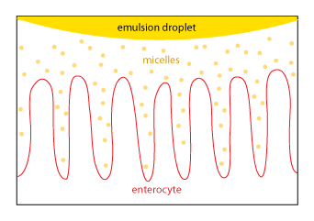<https://courses.washington.edu/conj/bess/fats/fats.html>

**Absorption**

Micelles are constantly breaking down and re-forming, feeding a small pool of monoglycerides and fatty acids that are in solution. Only freely dissolved monoglycerides and fatty acids can be absorbed, NOT the micelles. Because of their nonpolar nature, monoglycerides and fatty acids can just diffuse across the plasma membrane of the enterocyte. Some absorption may be facilitated by specific transport proteins (for instance see below, for cholesterol). (Washington, 11/1/2018).

**Chylomicrons**

Once inside the enterocyte, monoglycerides and fatty acids are re-synthesized into TAG. The TAG is packaged, along with cholesterol and fat soluble vitamins, into chylomicrons. Chylomicrons are lipoproteins, special particles that are designed for the transport of lipids in the circulation. You can review the structure of lipoproteins by visiting the web page on lipoproteins from fall quarter.

Chylomicrons are released by exocytosis at the basolateral surface of the enterocytes. Because they are particles, they are too large to enter typical capillaries. Instead they enter lacteals, lymphatic capillaries that poke up into the center of each villus. Chylomicrons then flow into the circulation via lymphatic vessels, which drain into the general circulation at the large veins in the chest.

Chylomicrons deliver absorbed TAG to the body's cells. TAG in chylomicrons and other lipoproteins is hydrolyzed by lipoprotein lipase, an enzyme that is found in capillary endothelial cells. Monoglycerides and fatty acids released from digestion of TAG then diffuse into cells. (Washington, 11/1/2018).

The figure at the right summarizes the various steps involved in fat absorption.

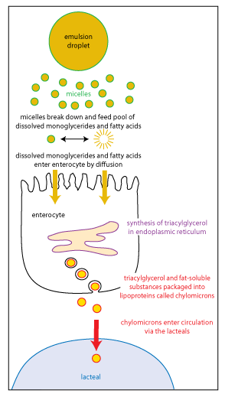<https://courses.washington.edu/conj/bess/fats/fats.html>

**Cholesterol absorption**

Intestinal cholesterol absorption is important because of the clinical relevance of cholesterol: high levels of low-density lipoprotein (LDL) cholesterol in the circulation increase the risk for the development of atherosclerosis. As shown in the figure, some of the cholesterol in the small intestine is dietary cholesterol, and some is put there by the liver, arriving via the bile. Of the total cholesterol that passes through the small intestine, only half is typically absorbed, and the rest is eliminated in the feces. Thus, cholesterol in the bile is an example of a substance that is targeted for excretion via the digestive tract.

The drug ezetimibe blocks a protein that specifically mediates cholesterol transport across the apical plasma membrane of enterocytes. Ezetimibe has been shown to be effective at reducing levels of LDL cholesterol, particularly when combined with a statin, a drug that inhibits cholesterol synthesis in the liver. The most recent results of a large clinical trial show that further lowering of LDL cholesterol with a combination of ezetimibe and a statin provides a modest benefit in lowering the risk of myocardial infarction and stroke. (Washington, 11/1/2018).

1. **Describe the absorption of minerals, especially iron.**

Iron homeostasis is regulated at the level of intestinal absorption, and it is important that adequate but not excessive quantities of iron be absorbed from the diet. Inadequate absorption can lead to iron-deficiency disorders such as anemia. On the other hand, excessive iron is toxic because mammals do not have a physiologic pathway for its elimination.

Iron is absorbed by villus enterocytes in the proximal duodenum. Efficient absorption requires an acidic environment, and antacids or other conditions that interfere with gastric acid secretion can interfere with iron absorption.

Ferric iron (Fe+++) in the duodenal lumen is reduced to its ferrous form through the action of a brush border ferrireductase. Iron is the cotransported with a proton into the enterocyte via the divalent metal transporter DMT-1. This transporter is not specific for iron, and also transports many divalent metal ions.

Once inside the enterocyte, iron follows one of two major pathways. Which path is taken depends on a complex programming of the cell based on both dietary and systemic iron loads:

Iron abundance states: iron within the enterocyte is trapped by incorporation into ferritin and hence, not transported into blood. When the enterocyte dies and is shed, this iron is lost.

Iron limiting states: iron is exported out of the enterocyte via a transporter (ferroportin) located in the basolateral membrane. It then binds to the iron-carrier transferrin for transport throughout the body.

Iron in the form of heme, from ingestion of hemoglobin or myoglobin, is also readily absorbed. In this case, it appears that intact heme is take up by the small intestinal enterocyte by endocytosis. Once inside the enterocyte, iron is liberated and essentially follows the same pathway for export as absorbed inorganic iron. Some heme may be transported intact into the circulation. (Andrews NC, 1986, 1999).

1. **Describe and explain the classification of amino acids according to their chemical and nutritional properties.**

Amino acids are organic molecules that, when linked together with other amino acids, form a [protein](https://www.thoughtco.com/proteins-373564). Amino acids are essential to life because the proteins they form are involved in virtually all [cell](https://www.thoughtco.com/facts-about-cells-373372) functions. Some proteins [function](https://www.thoughtco.com/protein-function-373550) as enzymes, some as [antibodies](https://www.thoughtco.com/antibodies-373557), while others provide structural support. Although there are hundreds of amino acids found in nature, proteins are constructed from a set of 20 amino acids. (Regina Bailey, August 30, 2018).

 Basic Amino Acid Structure: alpha carbon, hydrogen atom, carboxyl group, amino group, "R" group (side chain). [Amino acids](https://www.thoughtco.com/amino-acids-characteristics-608190) have the following structural properties:

* A carbon (the alpha carbon)
* A hydrogen atom (H)
* A Carboxyl group (-COOH)
* An Amino group (-NH2)
* A "variable" group or "R" group

All amino acids have the alpha carbon bonded to a hydrogen atom, carboxyl group, and amino group. The "R" group varies among amino acids and determines the differences between these protein monomers. The amino acid sequence of a protein is determined by the information found in the cellular [genetic code](http://www.thoughtco.com/genetic-code-373449). The genetic code is the sequence of nucleotide bases in [nucleic acids](https://www.thoughtco.com/nucleic-acids-373552) ([DNA](https://www.thoughtco.com/dna-373454) and [RNA](https://www.thoughtco.com/rna-373565)) that code for amino acids. These [gene](https://www.thoughtco.com/genes-373456) codes not only determine the order of amino acids in a protein, but they also determine a protein's structure and function. (Regina Bailey, August 30, 2018).

**Amino Acid Groups**

Amino acids can be classified into four general groups based on the properties of the "R" group in each amino acid. Amino acids can be polar, nonpolar, positively charged, or negatively charged. Polar amino acids have "R" groups that are hydrophilic, meaning that they seek contact with aqueous solutions. Nonpolar amino acids are the opposite (hydrophobic) in that they avoid contact with liquid. These interactions play a major role in protein folding and give proteins their [3-D structure](https://www.thoughtco.com/protein-structure-373563). Below is a listing of the 20 amino acids grouped by their "R" group properties. The nonpolar amino acids are hydrophobic, while the remaining groups are hydrophilic.

**Nonpolar Amino Acids**

* Ala: Alanine            **Gly**: Glycine              **Ile**: Isoleucine            **Leu**: Leucine
* Met: Methionine   **Trp**: Tryptophan    **Phe**: Phenylalanine     **Pro**: Proline
* **Val**: Valine

**Polar Amino Acids**

* **Cys**: Cysteine          **Ser**: Serine            **Thr**: Threonine
* **Tyr**: Tyrosine         **Asn**: Asparagine   **Gln**: Glutamine

**Polar Basic Amino Acids (Positively Charged)**

* **His**: Histidine        **Lys**: Lysine            **Arg**: Arginine

**Polar Acidic Amino Acids (Negatively Charged)**

* **Asp**: Aspartate       **Glu**: Glutamate

While amino acids are necessary for life, not all of them can be produced naturally in the body. Of the 20 amino acids, 11 can be produced naturally. These nonessential amino acids are alanine, arginine, asparagine, aspartate, cysteine, glutamate, glutamine, glycine, proline, serine, and tyrosine. With the exception of tyrosine, nonessential amino acids are synthesized from products or intermediates of crucial metabolic pathways. For example, alanine and aspartate are derived from substances produced during [cellular respiration](https://www.thoughtco.com/cellular-respiration-process-373396). Alanine is synthesized from pyruvate, a product of [glycolysis](https://www.thoughtco.com/steps-of-glycolysis-373394). Aspartate is synthesized from oxaloacetate, an intermediate of the [citric acid cycle](https://www.thoughtco.com/citric-acid-cycle-373397). Six of the nonessential amino acids (arginine, cysteine, glutamine, glycine, proline, and tyrosine) are considered conditionally essential as dietary supplementation may be required during the course of an illness or in children. Amino acids that cannot be produced naturally are called essential amino acids. They are histidine, isoleucine, leucine, lysine, methionine, phenylalanine, threonine, tryptophan, and valine. Essential amino acids must be acquired through diet. Common food sources for these amino acids include eggs, soy protein, and whitefish. Unlike humans, [plants](https://www.thoughtco.com/what-is-a-plant-cell-373384) are capable of synthesizing all 20 amino acids. (Regina Bailey, August 30, 2018).

**References**

<https://my.clevelandclinic.org/health/articles/7041-the-structure-and-function-of-the-digestive-system>

<https://opentextbc.ca/anatomyandphysiology/chapter/23-3-the-mouth-pharynx-and-esophagus/>

<http://www.vivo.colostate.edu/hbooks/pathphys/digestion/smallgut/absorb_minerals.html>

<https://courses.washington.edu/conj/bess/fats/fats.html>

Andrews NC: Disorders of iron metabolism. New Eng J Med 341:1986, 1999

<http://www.cdc.gov/mmwr/preview/mmwrhtml/00038546.htm>.

National Digestive Diseases Information Clearinghouse/National Institute of Diabetes and Digestive and Kidney Diseases. [The Digestive System and How It Works.](http://digestive.niddk.nih.gov/ddiseases/pubs/yrdd/) Accessed 9/14/2018.

Merck Manual Home Health Handbook. [Overview of the Digestive System.](http://www.merckmanuals.com/home/digestive_disorders/biology_of_the_digestive_system/overview_of_the_digestive_system.html?qt=digestive&alt=sh) Accessed 9/14/2018.